FINAL PROJECT – Word Report

Stefan Grulović

Hristos Hristodoulou
Computer Science 205: Business Data Management
Fall 2016
Presentation

This application is attended to help a travel agency to better organize their reservations on different excursions/events. The company has 300 different reservations, 99 customers, 20 different excursions (events), which have different locations, ways of transportation and arrangements. The application is made so the organization is more efficient. This is accomplished by making separate tables which have distinct information making the program use less memory than having it all squeezed in one table. Also by designing special queries which are made to satisfy the needs of the company owners. This is done in order for the owners to make the decisions faster as well as for them to figure out what is the next best move for the company. Now that the information is sorted and processed the company owners can run their company better.

Table descriptions
There are 9 different tables in this application, and they are:
1) Reservation (reservation_id, customer_id, guide_id, excursion_id,
reservation_date, reservation_people, reservation_request, packet_id)
- reservation_id serves as a uniqe ID for reservation
- customer_id serves as a reference to the customer table
- guide_id serves as a reference to the guide table
- excursion_id, serves as a reference to the excursion table
- reservation_date contains the date of the reservation
- reservation_people contains number of people who are reserved on this name
- reservation_request contains a special request made by the customer
- packet_id serves as a reference to the packet table

2) Customer (customer_id, customer_name, customer_gender, membership_id,
customer_region, customer_address, customer_number)
- customer_id serves as a uniqe ID for customer
- customer_name contains the customer full name with the title
- customer_gender contains the gender
- membership_id serves as a reference to the membership table
- customer_region contains the customer region in the country
- customer_address contains the customers living address
- customer_number containg the customers number

3) Guide (guide_id, guide_name, guide_gender, guide_salary, guide_hire_date)
- guide_id serves as a uniqe ID for guide
- guide_name contains the guides name
- guide_gender contains the guides gender
- guide_salary contains guides salary
- guide_hire_date containg the guides date of hiring

4) Excursion (excursion_id, excursion_dep, excursion_ret, location_id
accomodation_id, transport_id)
- excursion_id serves as a unique ID for excursion
- excursion_dep contains the date of departure
- excursion_ret contains the date of return
- location_id serves as a reference to the location table
- arrangement_id serves as a reference to the arrangement table
- transport_id serves as a reference to the transport table

5) Packet (packet_id, packet_desc, packet_price, packet_insu,
packet_insu_price)
- packet_id serves as a uniqe ID for packet
- packet_desc contains the type of packet
- packet_price containg the packet price
- packet_insu contains information whether a person has or doesn’t have insurance
- packet_insu_price contains the price of the insurance

6) Membership (membership_id, membership_status, membership_type, membership_discount)
- membership_id serves as a uniqe ID for membership
- membership_status containg the status of membership
- membership_type contains what kind of membership the person has
- membership_discount show the discount that comes with the membership

7) Location (location_id, location_location, location_type, location_price)
- location_id serves as a uniqe ID for location
- location_location contains the location of the excursion
- location_type contains the type of location
- location_price contains the extra price of going there

8) Transport (transport_id, transport_type, transport_price)
- transport_id serves as a uniqe ID for transport
- transport_type contains the type of transport used
- transport_price contains the price of using this transport type

9) Arrangement (arrangement_id, arrangement_desc, arrangement_price)
- arrangement_id serves as a uniqe ID for arrangement
- arrangement_desc contains the description of the arrangement
- arrangement_price contains the price of staying there

In order to fully understand how these tables are connected with each other an ER Diagram is provided in Picture 1 on the next page, as well as a separate file that comes in the package.

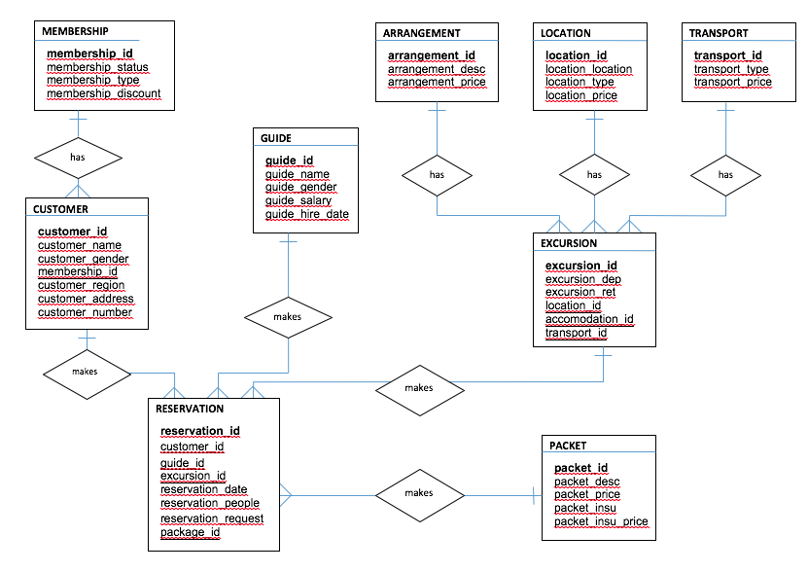
Picture 1. Displays the ER Diagram of the 9 different tables

Queries
1) Displays all the information combined in one table. The picture for this table can not be provided as the table is to big. The query is provided in the SQL dump file.
2) Display all the customers who don’t have a membership with the company, the table also contains their numbers and addresses. This is done in order to contact them fast and offer them to become a member.
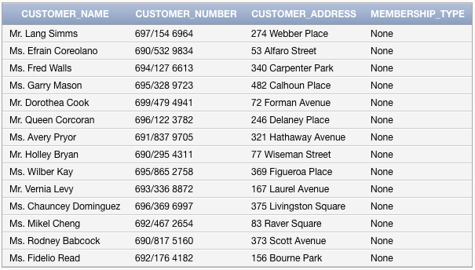

3) Displays how much each customer owes the company for the upcoming trips.
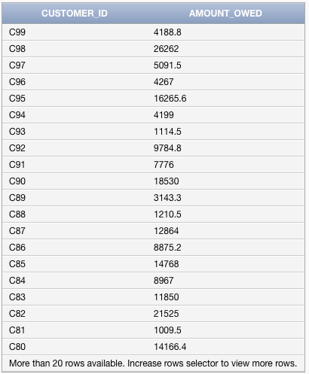

4) Displays a specific excursion and its location, days until departure, date of departure, days on the trip and the return date.

5) Displays all customer which have a special request and at the same time have a membership, while ordering by the membership type from higher status to lower.
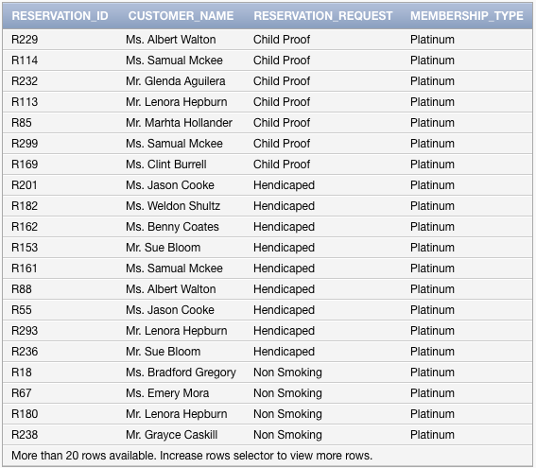

6) Displays the locations and their number of reservations.
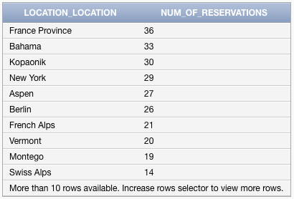

Suggestions for further development

This application can be further expanded by adding more information in the tables as well as further more defining and expanding on the price columns for each table. As this application was normalized immediately there is not much to change behind the logic of this application. Like mentioned, further developing and expanding on the logic behind storing the price information would help further develop this application. Because then the application would at the same time provide valuable information about the reservations as well as the expense behind them. Having this in one application would help to make easier conclusion and calculation which would in the end help the owners of the company.

